**Leader Overview**

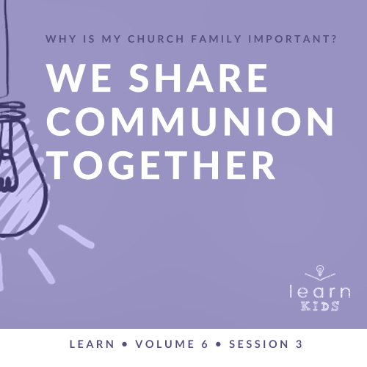

**Volume Overview**

**Why is my church family important?**

*When we think of church, it’s easy for our mind to be instantly drawn to the building where we attend. However, in God’s design, the church isn’t the building that we gather in. Instead, church has everything to do with the people who are gathered there. In essence, the biblical church is not a building that we go to but a family of believers that we belong to*.

*As our Father, God’s heart is to adopt us into His family (*[*Ephesians 1:5*](https://ref.ly/logosref/Bible.Eph1.5)*). When we choose to put our faith in Jesus, we instantly join God’s family. We not only belong to Him, but we also belong to each other. Just like our natural families here on earth were meant to function, God uses our church family to meet our needs. A healthy church family offers love, encouragement, guidance, and accountability. As the family of God—the Church—we grow together, celebrate together, share together, and even serve together. As we make a commitment to God’s family, we will become stronger, more devoted followers of Jesus*.

**Session Overview**

**We Share Communion Together**

*Before His death, Jesus ate a meal with His disciples that is now referred to as the Last Supper. While they were together, Jesus introduced the basic elements that make up what is now called Communion. This practice of sharing bread and the cup in remembrance of Jesus’ death and resurrection became a regular practice for the Early Church. For centuries, sharing Communion together has unified the Church with Jesus and each other*.

**Bible Lesson**

Disciples Share the Lord’s Supper

[Matthew 26:17–19](https://ref.ly/logosref/Bible.Mt26.17-19), [26–30](https://ref.ly/logosref/Bible.Mt26.26-30); [1 Corinthians 11:23–26](https://ref.ly/logosref/Bible.1Co11.23-26)

**Faith Fact**

We share together.

**Faith Verse**

[Matthew 18:20](https://ref.ly/logosref/Bible.Mt18.20) (NLT)

“For where two or three gather together as my followers, I am there among them.”

**Preparing for the Session**

**Leader Preparation Time: 20–25 Minutes**

|  |
| --- |
| ***You Will Need***  ***Large Group***   * *Bible* * *Worship songs (Song suggestions: “The Blessing” by Elevation Worship; “The Stand” by Hillsong United; “Broken Vessels” (Amazing Grace) by Hillsong Worship; “This Is a Move” by Bethel Music Worship)* * *For groups not using a phone or tablet only, add:*   *• Projector or TV*  *• Laptop*  *•* ***Faith Fact Slide***  *•* ***Faith Verse Video*** *or* ***Slide***  *•* ***Bible Lesson Video***  *•* ***Teaching Point Slides 1–3***   * *Bag of chips* * *Fast food meal or frozen dinner* * *Bread or crackers, enough for each kid* * *Grape juice, white or red, enough for each kid* * *Small cups, one per kid*   ***Small Group***   * *Bibles for kids in your group to share* * *Ball, one per group* * ***Small Group Activity Page****, one per kid* * *Crayons and markers*   *To access session content and videos from a computer, visit:* [*BibleEngagementProject.com/downloads*](https://bibleengagementproject.com/downloads) |
| ***Getting Ready***  ***For Session 6.4***   * *Order one or more magic towels (small towels that expand in water) for Kids 6.4 Teaching Time. Leader needs one towel. Optional: Buy enough towels to send one home with each kid.*   ***Large Group***   * *Download videos and slides if needed.* * *Select worship song(s) and have them ready to play.* * *Read the Bible Lesson Scripture to prepare for Teaching Time.* * *Prior to session, fill small cups with juice for all the kids.* * *Review the Communion options and choose one. If choosing option 3, you will want to contact parents a couple of days ahead so they can be prepared to be in the session.*   ***Small Group***   * *Print copies of the* ***Small Group Activity Page****, one per kid.*   *First time leading* Learn *for Kids? Check out the* [*Facilitator Guide*](https://0b769b0ed3569ef9d18b-f88d8272f61086866d50d048b43ef630.ssl.cf2.rackcdn.com/sites/biblengagementproject/Listen_Facilitator_Guide.pdf)*.* |

**Large Group**

**30 Minutes**

*See what’s needed at the beginning of the session.*

**Introduction**

Welcome everyone! I just love our church family. What about you? *(Group response)* We’ve been answering the question: Why is my church family important? If you love your church family, let them know. Turn to your neighbor and say, “You’re important!” *(Group response)*

Learning about our church family is a great reminder that we really need each other. We grow together and celebrate together. Today, we’ll learn how we can share something very special together. Raise your hand if you like to share. *(Group response)* Whether you’re a natural at sharing or not, God wants us to share with others, especially those who are a part of our church family.

**Faith Fact**

That’s why today’s Faith Fact is: **We share together**.

• *Show the* ***Faith Fact Slide***.

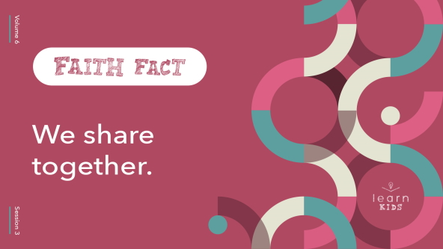

Instead of saying the Faith Fact all together, we’re going to share it individually with the people who are sitting next to us. Turn to someone and share the Faith Fact with them. **We share together**. *(Group response)* Now turn to another person and share the Faith Fact with them. **We share together**. *(Group response)* That was a great exercise in sharing with others. We’re going to do a lot more sharing today.

**Game**

**Share a Story**

Who enjoys a good story? *(Group response)* I’m not sure what’s more fun—sharing a story with someone or listening to a good story. In today’s game, we have a chance to do both. We’ll work together to create a story. Who knows where the story will go and how it will end? Let’s find out!

• *Optional: You might prefer to have each person share a sentence rather than a word. Start it out with, “Once upon a time …”*

I’ll start the story, then pass it on to all of you. There’s a catch. Each of us can only share one word *(or sentence)* of the story when it’s our turn. Are you ready to share a story together? *(Group response)*

• *Keep going until every kid has had a chance to add at least one word or sentence*.

• *If your group is smaller, go around the group a few times or until the story feels like it has ended*.

• *If your group is larger, consider dividing the group up and sharing multiple stories so that everyone can participate in sharing the story*.

That was such an interesting story we shared together! Even if it didn’t always make a lot of sense, it was fun to share it together just like our Faith Fact says. **We share together**.

**Worship**

Speaking of sharing together, worship is another thing that we do together. Do you love worshipping God? *(Group response)* I’d like three people to share one thing they love about worship. *(Allow responses.)* Those are great reasons to love worshipping God. Hearing the reasons you love worship made me think about why I love worshipping God.

• *Share one reason you love worshipping God before moving on*.

Let’s put that into practice and worship God together by singing right now.

• *Lead the kids in singing one or two praise songs. See suggestions at the beginning of the session*.

**Bible Lesson**

Another thing I love sharing with you is God’s Word. I never want to keep what I know about God’s Word to myself. Let’s take a moment to pray before we dig into God’s Word together.

**Prayer**

|  |
| --- |
| *Dear God, thank You for giving us the opportunity to share Your Word with one another. Help us to continue sharing what we learn today with others all week long. Amen.* |

**Video Intro**

Just before we look at the Bible story, let’s watch this video.

• *Play* ***Bible Lesson Video***.

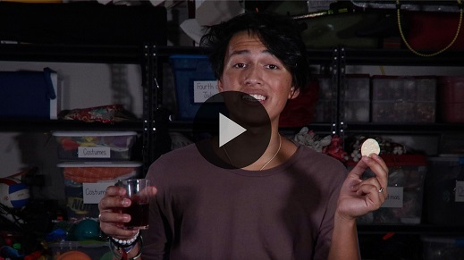

**Bible Story**

**Disciples Share the Lord’s Supper**

That video was such a fun lead-in to our Bible story today! We’ve been hearing from the Book of Acts for the last couple of sessions. Today, we’ll read in the Book of Matthew. Jesus was here on earth at this time, but He had only a few more days left with His disciples before His death on the Cross. Jesus wanted to share something special with them during their meal together.

Let’s read about what He shared with them. Grab your Bible or pull up a Bible app on your device. Turn to [Matthew 26:17–19](https://ref.ly/logosref/Bible.Mt26.17-19), [26–30](https://ref.ly/logosref/Bible.Mt26.26-30) first. Then, we’ll read [1 Corinthians 11:23–26](https://ref.ly/logosref/Bible.1Co11.23-26).

• *Read the Bible story aloud to the group*.

• *In order to keep Large Group time moving along, we don’t recommend having the kids read*.

• *Optional: Remind the kids to mark this place with their Bible Bookmark, so they can read it on their own at home*.

**Teaching Time**

|  |
| --- |
| ***You Will Need***   * ***Teaching Point Slides 1–3*** * *Bag of chips* * *Fast food meal or frozen dinner*   *No prep needed for this activity.* |

Can you imagine being one of Jesus’ disciples and sharing that meal with Him? *(Group response)* When they were together, Jesus used a couple of things from the meal to talk about something special with them. Who can remember what Jesus shared? *(Allow responses.)* Jesus shared the bread and the cup with them. Today, we call this Communion. Raise your hand if you’ve heard of Communion. *(Group response)*

Jesus and His disciples were eating a meal celebrating a Jewish festival called

Passover. This meal celebrated the time God delivered the Israelites from slavery in Egypt. You can read about that in the Book of Exodus. This Passover meal was different. Jesus assigned a new meaning to the bread and the cup that night. Today, Christians still take Communion, using the symbols of the bread and the cup.

Remember what our Faith Fact says? **We share together**. It’s always important for us to share with our church family, and sharing Communion is an important part of being part of a church. Like baptism in water, Communion can mean different things in different churches. It’s important to understand what Communion is and what it means to share it with our church family.

**1. Communion is about remembering Jesus**.

• *Show the* ***Teaching Point 1 Slide***.

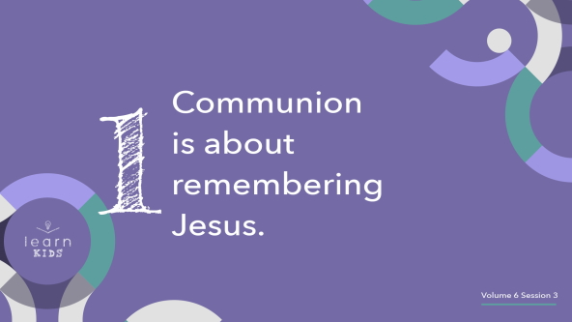

Jesus told His disciples to eat the bread and drink the juice as a way to remember what He did for us. These symbols represent His body and His blood that He gave for our sins. They help us to remember His life and His death.

Symbols remind us or help us remember something else. We have symbols, or logos, for many things. For example, we use the cross as a symbol for church and Christianity. What are some other symbols that you recognize? Think about stores you go to or restaurants you eat at. You might even have some logos or symbols on your clothing right now. *(Allow responses.)*

At Communion, the symbols of the bread and the cup remind us of what Jesus did for us. His body was broken for us and His blood was shed for us on the Cross. It might be difficult, sad, or even painful for us to think about that, but it’s important that we never forget the sacrifice Jesus made for us so many years ago. If Jesus had not died, He wouldn’t have had the opportunity to come back to life. Through Jesus’ death and resurrection, He was able to conquer sin and death once and for all.

**2. Communion is a holy time shared with other believers**.

• *Show the* ***Teaching Point 2 Slide***.

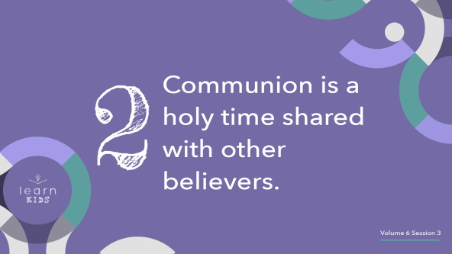

Even though we believe that the bread and juice are only symbols, we should not take Communion lightly or as if it’s not important. It’s not like eating a snack because you’re hungry.

• *Pull out a bag of chips, open it, and eat some chips while you talk. Then, set it aside*.

Taking Communion is important because Jesus commanded us to do it. In [1 Corinthians 11](https://ref.ly/logosref/Bible.1Co11), Paul told us there are consequences for taking Communion lightly. He reminded us to examine our heart and life for any sin before we take Communion. That’s why the pastor usually offers a time to pray and ask God to forgive any unresolved sin in your life.

**3. Communion unifies us with Jesus and other believers**.

• *Show the* ***Teaching Point 3 Slide***.

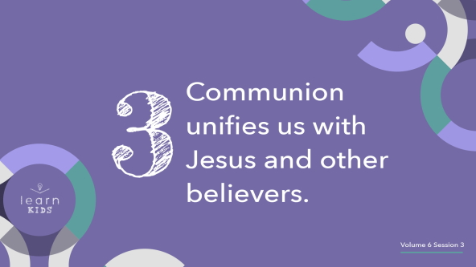

Communion should only be taken by those who are Christians and committed to following Jesus in what they say and do. When you look at when Jesus introduced Communion to His disciples, it was during His last meal with them before His death. Jesus didn’t choose to do this when He was alone and talking with God in the Garden before He was arrested. He chose to share it with His disciples.

Jesus created Communion as something believers do together. Today, we share Communion because Jesus set that example for us with His own disciples. Why do you think it’s important to take Communion together instead of alone? *(Allow responses.)*

• *Hold up the fast food meal or frozen dinner*.

Imagine eating this meal alone. No one is around to talk to while you it. It’s just you and the food. Raise your hand if you’d enjoy that. *(Group response)* Now imagine eating this same meal with the people you love to be with the most. Raise your hand if you’d enjoy that more than eating alone. *(Group response)* How does eating a meal together change things? *(Allow responses.)*

We should take Communion together. It’s a practice that unifies us with our church family. When we share memorable events, such as water baptism and Communion together, we become closer to each other. As we take the bread and juice, it also unifies us with Jesus. It’s similar to how we share in Jesus’ death and resurrection through water baptism. But, being baptized in water is something we only need to do once after we become a Christian. Communion is a special time we can continue to share with each other regularly to remember what Jesus did for us on the Cross.

**Prayer and Response**

*Consider playing a worship song softly in the background while kids pray*.

|  |
| --- |
| ***You Will Need***   * *Bread or crackers, enough for each kid* * *Grape juice, white or red, enough for each kid* * *Small cups, one per kid*   ***Getting Ready***   * *Prior to session, fill small cups with juice for all the kids.* * *Review the Communion options and choose one. If choosing option 3, you will want to contact parents a couple of days ahead so they can be prepared to be in the session.* |

When we share Communion with other believers, we use things that are similar to what Jesus used with His disciples during the Last Supper: bread and a cup of juice.

• *Show these items to the group*.

When we eat the bread and drink the juice, we remember what Jesus has done for us.

• *Proceed with the option you’ve chosen for Communion, if applicable:*

• *Communion Option 1: In Large Group. Offer Communion to everyone now. Remind the kids that Communion should only be taken if they are a Christian and have examined their life for sin first. Communion is not a snack and should be taken with reverence and respect*.

• *Communion Option 2: In Small Groups. Dismiss kids to small groups and offer Communion*.

• *Communion Option 3: Family Communion. Invite the parents to join your service and have them take Communion together as a family. This gives the opportunity for parents to choose if they think their kid is old enough to understand Communion and brings the families together for this holy moment*.

**Sample Communion Service**

Jesus’ Last Supper with His disciples was the very first Communion. The parts of the meal that He shared with them were the bread and the cup. What we are taking now are the bread and grape juice.

Before we take Communion together, I want to remind all of us about some important parts. First, Communion is for those who are believers in Jesus. If you’ve made the choice to ask Him to forgive you for the wrong things you’ve done, you’re ready to take Communion with other believers. Second, Communion is all about remembering what Jesus has done for us.

• *Give each kid a piece of bread and have them hold it*.

Jesus took the bread and gave thanks to God for it. Then He broke it in pieces and gave it to the disciples, saying, “This is my body, which is given for you. Do this in remembrance of me.” He was telling the disciples that His body would be hurt to pay the price for everyone’s sins. He wants us to remember this each time we eat the Communion bread. Let’s pray and then we’ll eat the bread. Repeat after me.

Jesus, thank You for giving Your body. Thank You for dying in my place. I remember Your great gift today. Amen.

• *Have kids eat their bread*.

• *Give each kid a serving of grape juice and have them hold it*.

Next, Jesus took the cup with the grape juice in it*.* He said, “This represents my blood which is poured out for the forgiveness of sins.” Was Jesus’ death a good thing? *(Group response)* Yes, it was good because it made a way for our sins to be forgiven. Jesus is the only Person who never sinned. He is the only One who could die to pay for our sins. That’s what we remember when we drink the Communion juice. Let’s pray and then we’ll drink the juice. Repeat after me.

Jesus, thank You for taking the punishment for my sins and the sins of everyone else. You must love us a lot. Today I remember all that You’ve done for me. Thank You for forgiving me. I love You and thank You for loving me so much. Amen.

• *Have kids drink their grape juice*.

• *Tell kids what to do with their empty cups*.

Let’s pray together.

**Prayer**

• *Optional: Have the kids repeat phrases of the prayer after you*.

|  |
| --- |
| Dear God, thank You for giving us Communion to share with each other. When we see the symbols of the bread and the cup, help us to remember the sacrifice Jesus made for us. Amen |

**Faith Verse**

It was probably really special for Jesus’ disciples to have the opportunity to eat the bread and drink the cup with Him in person. God is here with us today. Our Faith Verse reminds us of that. Let’s say our Faith Verse and do the actions together.

• *Play* ***Faith Verse Video***.

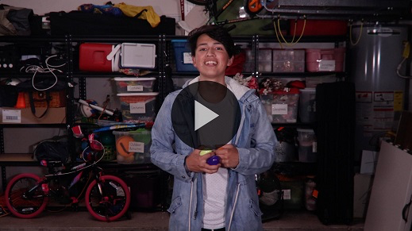

[Matthew 18:20](https://ref.ly/logosref/Bible.Mt18.20) (NLT)

“For where two or three gather together as my followers, I am there among them.”

When we gather together as a church family, God meets us. How could we ever want to miss out on that?

**Faith Fact**

Before we go to our small groups, let’s review our Faith Fact another time.

• *Show the* ***Faith Fact Slide***.



Say it with me. **We share together**. We’ll continue to share together in our Small Group time. Let’s go!

• *Dismiss kids to Small Group time or to go home if your group time ends here*.

**Small Group**

**30 Minutes**

*This section can be done in conjunction with the large group or on its own if you do small groups with your kids. During Small Group time, the goal is to connect the kids with the Word of God and to each other. All activities are led by the small group leader.*

**Group Connection**

**Share Something**

One of the great things about having a church family is having people to share things with. We can share many things with each other. Sharing comes easy for some people, but it’s harder for others. Why is that? *(Allow responses.)*

Sharing things with others, especially personal details about your life, requires a level of trust. We want to be sure that the other person won’t make fun of us or talk to others about us. We should be able to trust our church family so that we can share with them both the good and the bad things that happen in our life.

Let’s start off small by sharing something with each other. You don’t have to share something big or super personal, but please share something truthful with the group. I’ll go first!

• *Share something about yourself that the kids don’t already know*.

• *Go around the circle, allowing everyone the chance to share something about themselves with the group*.

• *Optional: Go around the group several times, allowing kids to share more things about themselves with the group if you have time*.

It’s so great getting to know all of you better. Thanks for sharing some of the details about your life with us. That’s what our Faith Fact reminds us to do. Say it with me. **We share together**.

**Learn about It**

|  |
| --- |
| ***You Will Need***   * *Bibles for kids in your group to share*   *No prep needed for this activity.* |

**Scripture Search:** [**John 6:53–59**](https://ref.ly/logosref/Bible.Jn6.53-59)**;** [**Isaiah 53:3–6**](https://ref.ly/logosref/Bible.Is53.3-6)**;** [**1 Corinthians 10:16–17**](https://ref.ly/logosref/Bible.1Co10.16-17)**;** [**1 Corinthians 11:27–31**](https://ref.ly/logosref/Bible.1Co11.27-31)

Let’s see what else God’s Word has to say about the importance of sharing Communion, which is remembering what Jesus suffered for us on the Cross. As we find and read each of these verses, let’s consider: What does this Scripture mean for our life today?

• *Give each kid a Bible and search for one or more of the Scriptures as a group together (as time allows). When everyone has found the Scripture, have one of the kids read it. Then, answer the questions about it*.

• *Pair kids who need additional help with older kids or start simple and look up the session’s Bible story Scripture:* [*Matthew 26:17–19*](https://ref.ly/logosref/Bible.Mt26.17-19)*,* [*26–30*](https://ref.ly/logosref/Bible.Mt26.26-30)*;* [*1 Corinthians 11:23–26*](https://ref.ly/logosref/Bible.1Co11.23-26)*. Kids will get better finding Scriptures the more they practice*.

• *Optional: Make this a competition to see who can find the Scripture first*.

**Bible Reading Tip**

Did you know God wants to share things with us every day? He does that through His Word. Do you struggle with remembering to read your Bible every day? *(Group response)* Do you find it hard to stick to a Bible reading plan and give up before you finish it? *(Group response)*

If you answered yes to either of those questions, you’re not alone. Finding a partner might help you stay on track with your personal Bible reading goals. In fact, choosing a Bible reading plan to do with someone else or even a group of friends can be a lot of fun. It’s a great way to share God’s Word with each other. You’ll learn new things together. Plus, you can keep each other accountable for spending time with God.

**Challenge**

God’s Word isn’t meant to be read or even memorized and then kept to ourself. The Bible is the living Word of God, and it’s meant to be shared with others. It’s the most powerful tool and weapon we could possibly have.

Do you have a favorite verse or verses in the Bible? *(Group response)* If not, I challenge you to find a verse you love in God’s Word this week. When you’ve chosen a favorite verse, take the time to memorize that verse. Then, share it with someone you think might be encouraged by it.

**Faith Fact**

Sharing is an important part of life, but even more so when we’re a part of a church family. Let’s say our Faith Fact together. **We share together**.

**Group Discussion**

*Feel free to use all or just a few questions as a jumping-off place for good discussion. Questions marked with * are designed for more conversation. Adjust the questions based on the age or maturity of your group. Typically, older kids will be able to dive a little deeper than younger ones*.

**Questions**

• *If small group activities are not immediately following large group time, you may want to read the Bible story passage before this discussion*.

* Why is it important to share with others?

What was the name of the meal Jesus shared with His disciples?

What did the bread and the cup represent? See [Matthew 26:26–27](https://ref.ly/logosref/Bible.Mt26.26-27).

Why should we take Communion?

Have you taken Communion before? Why or why not?

* What does Communion mean to you?

* In addition to Communion, what’s something else we can share with our church family?

Is it hard or easy for you to share? Why?

What’s something that is hard for you to share?

Is there anyone you find it hard to share with? Why is that so?

**Prayer Requests**

*Finish group discussion by sharing prayer requests and praise reports. Keep track of your small group’s prayer requests and review them each time you meet*.

**Prayer**

*Have kids pray for each other’s prayer requests*.

**Faith Verse Review**

|  |
| --- |
| ***You Will Need***   * *Ball, one per group*   *No prep needed for this activity.* |

When we gather together at church, we can practice sharing things with each other. We can share information about how our week is going, what we need prayer for, and even our belongings. Our Faith Verse reminds us that God is with us when we’re together. Let’s review it now.

• *Show* ***Faith Verse Video***.



[Matthew 18:20](https://ref.ly/logosref/Bible.Mt18.20) (NLT)

“For where two or three gather together as my followers, I am there among them.”

Say the Faith Verse with me again. If you haven’t done so already, try to memorize it. We’ll be sharing the verse together during today’s game, and you don’t want to drop the ball.

* *Say the verse as a group a couple of times*.

**Faith Verse Fun**

**Share the Verse**

Who thinks they already know the Faith Verse? *(Group response)* From what I heard, many of you have memorized it or are close to memorizing it. We’ll need everyone to work together to share the verse today.

• *Hold up the ball*.

We’re going to pass this ball around the group. When someone shares the ball with you, say the next word of the Faith Verse. We’ll keep passing the ball around the group until we’ve shared the entire verse. Let’s see how fast we can say the verse together!

• *When you’re done, play more rounds, attempting to get faster at sharing the verse each time. As a variation, allow kids to roll the ball across the group rather than pass it to the next person*.

• *Optional: If the group is mostly younger kids, have everyone say each word of the verse together*.

I think we did a great job sharing the Faith Verse together. Each time we said it, we got faster and better at sharing together. Great job!

**Activity Page**

**Communion**

|  |
| --- |
| ***You Will Need***   * ***Small Group Activity Page****, one per kid* * *Crayons or markers*   ***Getting Ready***  *• Print copies of the* ***Small Group Activity Page****, one per kid.* |

While they were together, Jesus shared a meal with His disciples that we now celebrate as Communion. He wants us as a church family to share Communion together using the same symbols that His disciples used.

• *Give a copy of the* ***Small Group Activity Page*** *and crayons to each kid*.

What do the bread and cup represent in Communion? *(Allow responses.)* Remembering what Jesus did for each of us on the Cross is important. As you color the picture, let’s talk about how we can share with others what Jesus did for us.

• *Lead kids in a discussion to share ideas about how to reach others*.

**Dismissal**

Thanks for sharing your time and energy with me today. I hope you’ll take this idea of sharing into your week and think about sharing with others more than ever. Let’s pray.

**Prayer**

|  |
| --- |
| *Dear God, thank You for reminding us of the importance of sharing with others, especially those we call our church family. Help us to be people who share this week. Amen.* |

**Faith Fact Recap**

• *Show the* ***Faith Fact Slide***.



Let’s say the Faith Fact one more time together. This time, I want you to share it with me, and I’ll just listen. Let me hear it. **We share together.** Thanks for giving me a break and sharing the Faith Fact with me. Don’t forget to share what you learned today with others this week. See you next time!

• *Send home the* ***Small Group Activity Page***.

• *Remind parents that there are* ***Family Devotions*** *available on the app to do with their kid*.

• *Tell everyone the date and time for the next session*.